EXPERIMENT REPORT - 3
Design and Simulation of a Current-Series Feedback Amplifier Using BJT

1. Objective
To design and simulate a current-series feedback amplifier using a 2N3904 BJT in LTspice, observe the input and output waveforms, and study the effect of feedback on amplifier gain.

2. Components and Values
Component | Value
Q1 | 2N3904 NPN transistor
V2 | 12 V DC supply
V1 | SINE(0 10m 1k)
R1 | 1 kΩ
R2 | 47.5 kΩ
R3 | 10 kΩ
R4 | 4.7 kΩ
R5 | 1 kΩ
R6 | 10 kΩ
R7 | 10 kΩ
C1 | 10 µF
C2 | 10 µF
Transient analysis | .tran 10m

3. Circuit Diagram

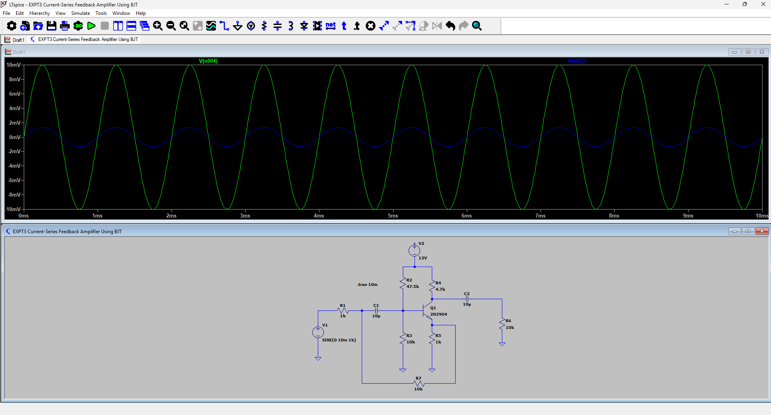
The following diagram is the LTspice circuit and transient waveform screenshot supplied for this experiment
4. Procedure
- Open LTspice and create a new schematic.
- Place a 2N3904 NPN transistor, a 12 V DC supply, resistors, coupling capacitors, and the input voltage source.
- Connect the components according to the circuit diagram and ensure that the ground connections are correctly placed.
- Set the component values as listed in the table and set V1 to SINE(0 10m 1k).
- Add the transient analysis directive .tran 10m.
- Run the simulation and plot the input waveform at the input node and the output waveform at the node after capacitor C2 across load resistor R6.
- Compare the amplitudes and phase relationship of the input and output waveforms.

5. Output Graph
The transient simulation shows a 1 kHz sinusoidal input with an amplitude of approximately 10 mV peak. The plotted output after C2 is smaller than the input and is approximately in phase in the supplied screenshot. This is the observed simulation result; an ideal common-emitter amplifier is normally expected to produce an inverted output, so the bias and feedback connections should be verified if inversion is required.

6. Result
The current-series feedback amplifier circuit using a 2N3904 BJT was constructed and simulated in LTspice. The input and output waveforms were obtained and examined. The observed output amplitude was smaller than the input in the supplied simulation; further bias and feedback verification is recommended if an amplified, inverted output is required.

7.Reflection
The simulation provided practical experience in constructing a BJT amplifier in LTspice and observing its transient response. The input and output waveforms were compared, and the effect of resistor values, transistor biasing, coupling capacitors, and feedback connections on the output was considered. The results also showed the importance of checking the correct output node and verifying the transistor operating point before adjusting component values.

